Ideation Phase
Define the Problem Statements

Date | 30 October 2026
Team ID | NA
Project Name | Electric Vehicle Market Performance & Insights
Maximum Marks | 2 Marks

Customer Problem Statement Template:
Create a problem statement to understand your customer's point of view. The Customer Problem Statement template helps you focus on what matters to create experiences people will love.
A well-articulated customer problem statement allows you and your team to find the ideal solution for the challenges your customers face. Throughout the process, you’ll also be able to empathize with your customers, which helps you better understand how they perceive your product or service.

Reference: https://miro.com/templates/customer-problem-statement/
Filled problem statements:
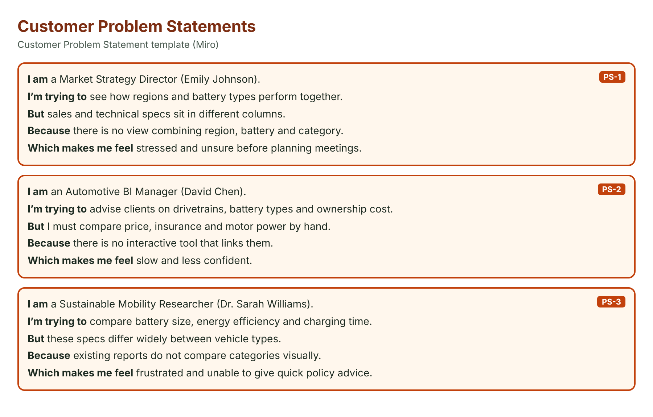
Problem Statement (PS) | I am (Customer) | I’m trying to | But | Because | Which makes me feel
PS-1 | a Market Strategy Director (Emily Johnson) | see how regions and battery types perform together | sales and technical specs sit in different columns | there is no view combining region, battery and category | stressed and unsure before planning meetings
PS-2 | an Automotive BI Manager (David Chen) | advise clients on drivetrains, battery types and ownership cost | I must compare price, insurance and motor power by hand | there is no interactive tool that links them | slow and less confident
PS-3 | a Sustainable Mobility Researcher (Dr. Sarah Williams) | compare battery size, energy efficiency and charging time | these specs differ widely between vehicle types | existing reports do not compare categories visually | frustrated and unable to give quick policy advice

